**What is Amazon Cloud Watch?**

Amazon CloudWatch provides cloud-based monitoring for EC2 instances, elastic, load balancers, auto-scaling groups along with other AWS services like Amazon S3, SNS, SQS, and RDS. It can be easily monitored from a centralized dashboard.

**CloudWatch can also be used to**:

* Visualize and analyse the data with end-to-end observability.
* Create custom dashboards that include metrics of the AWS services that you use.
* Improve Operational Performance using alarms and automated actions
* Gain complete visibility into application performance, utilization of AWS resources, and overall health of your operations.

Let’s get create a Cloud Watch for a EC2 Instance and Trigger an alarm at 50 % CPU utilization.

Navigate to EC2 Service and Launch an Instance.

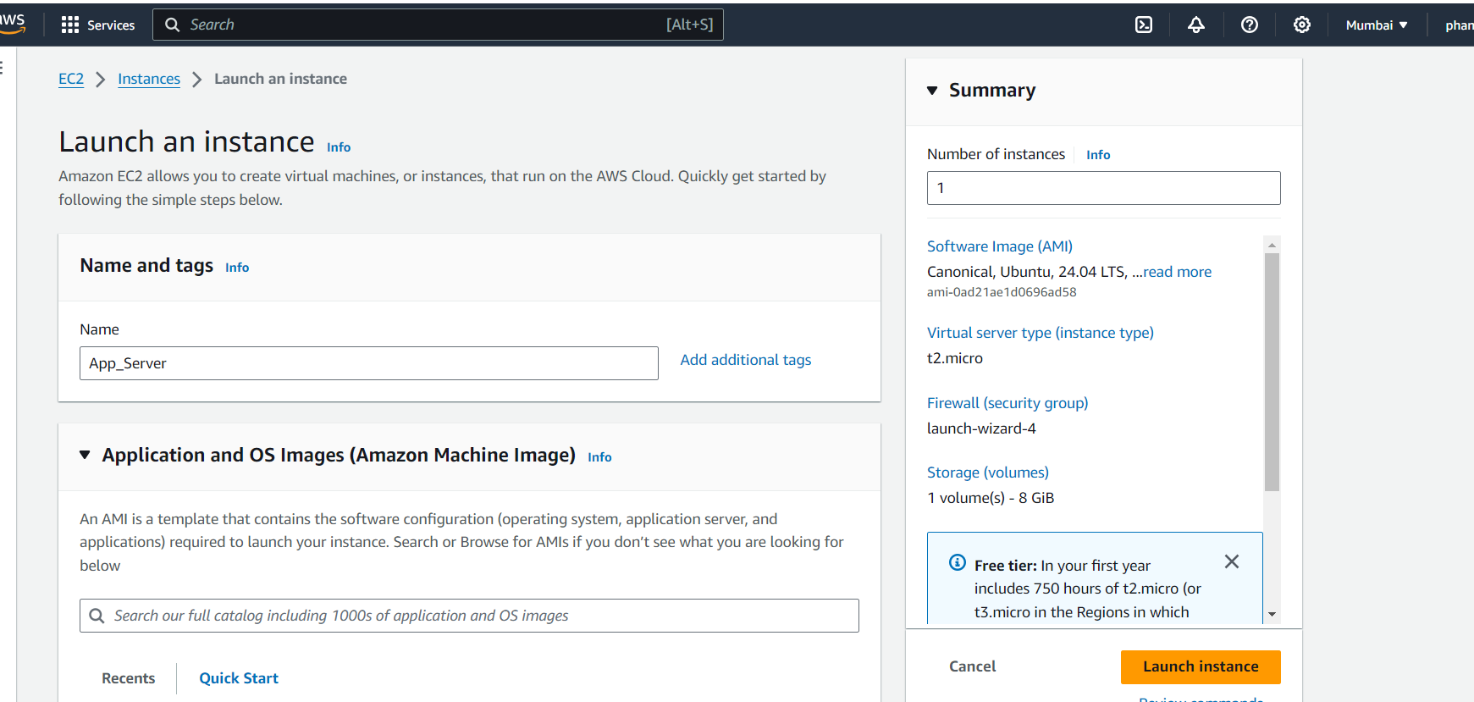

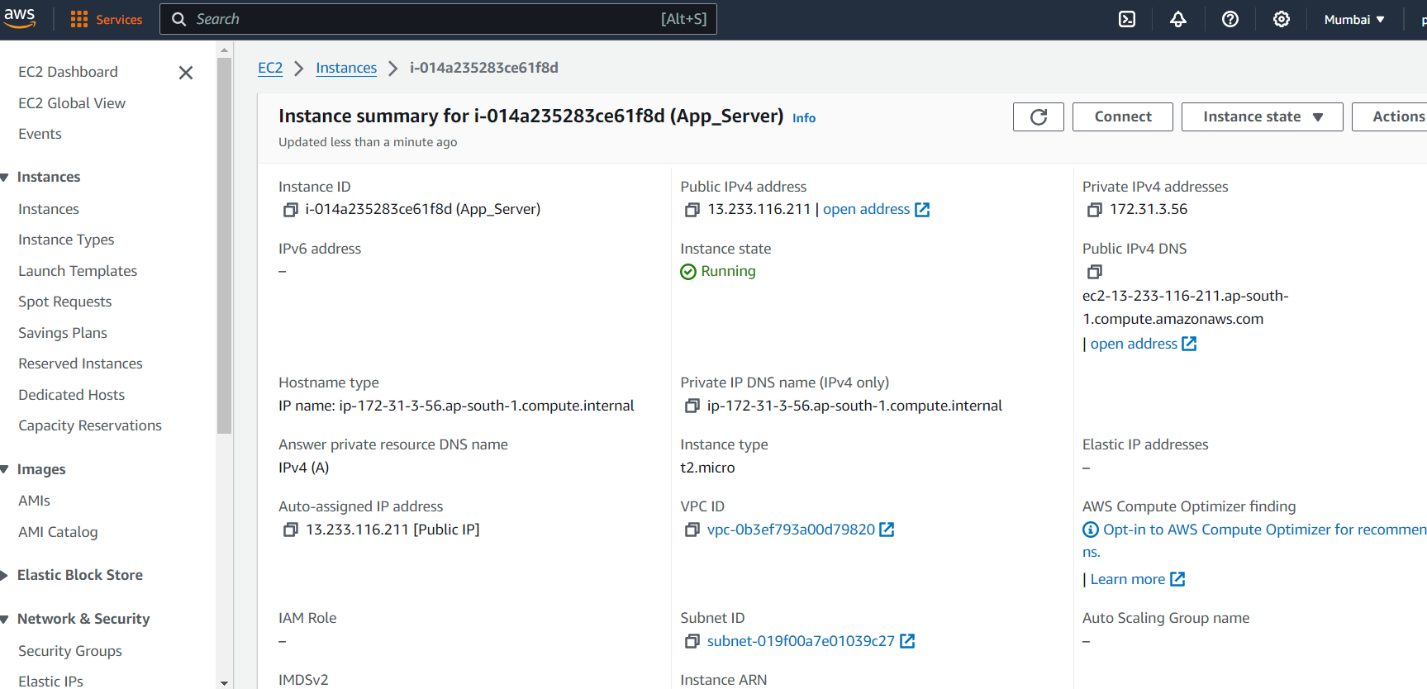

Connect to the Instance Via Putty and Do

$ sudo apt update

Use top Command to check the CPU Processes

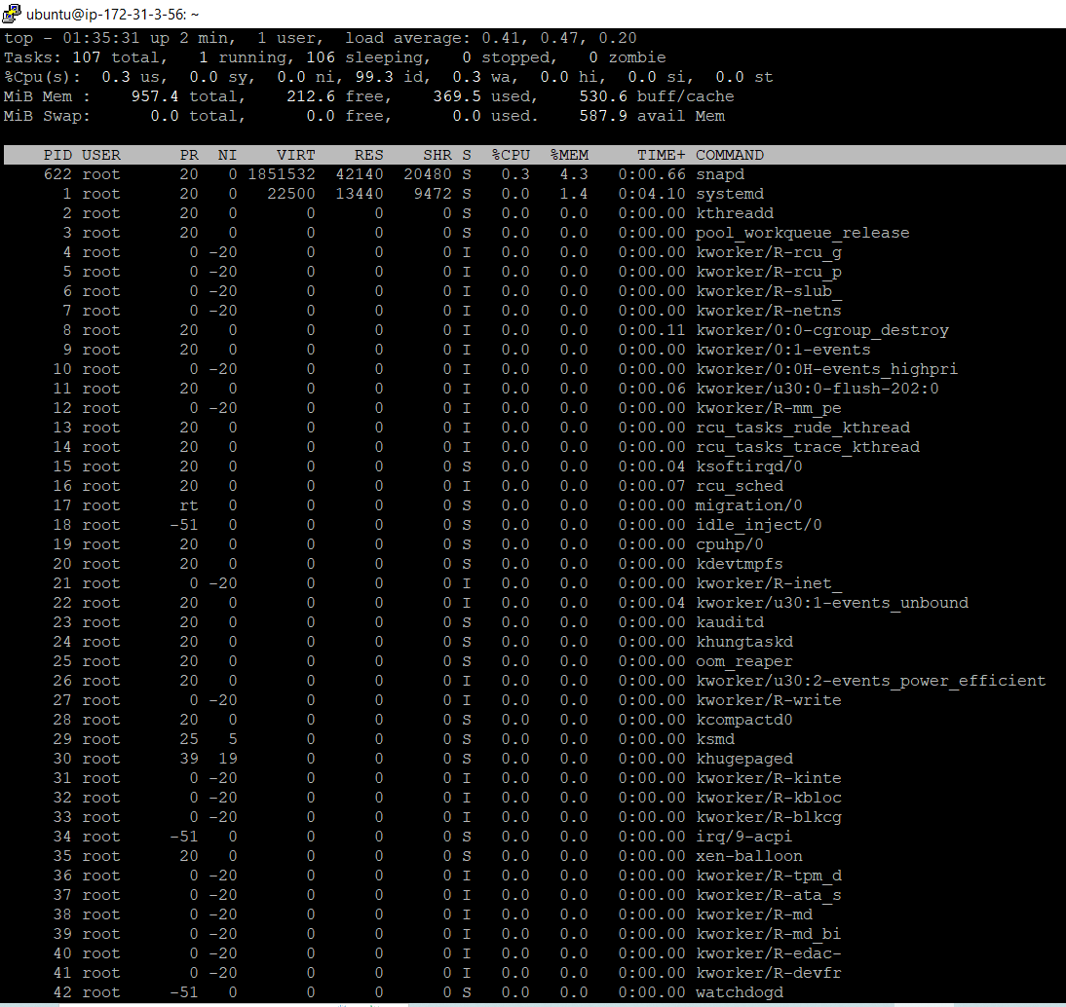

Navigate to Cloud Watch Dashboard and Check the Launched EC2 CPU Utilization Metrics.

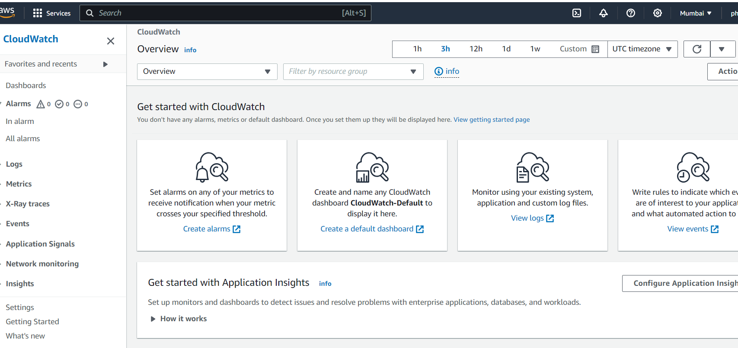

Navigate to EC2 instance and to the Monitoring Tab here we can see other default metrics also.

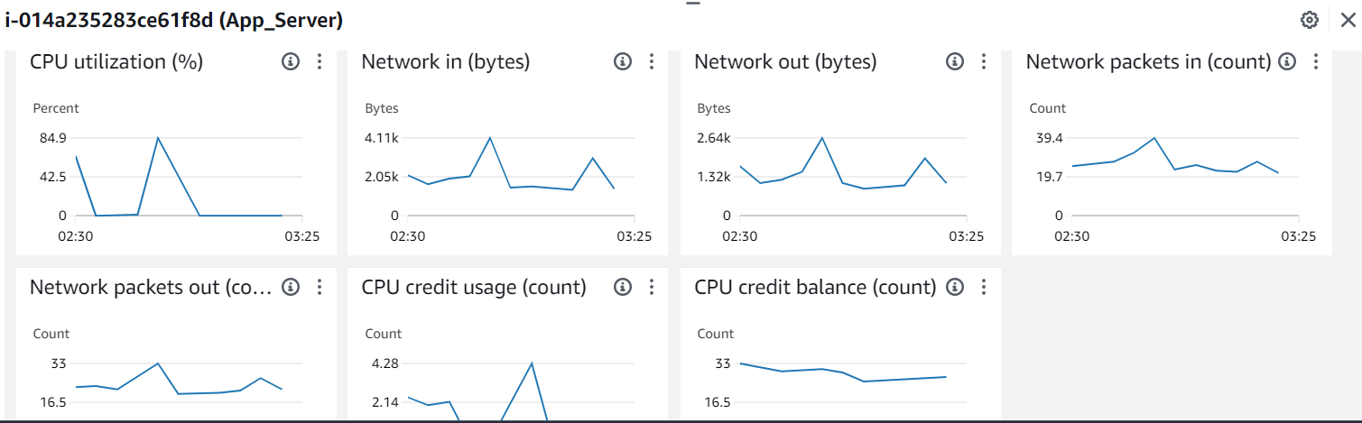

Create a cpu_spike.py file

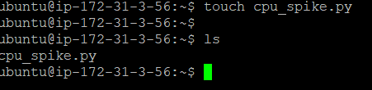

Vim cpu_spike,py

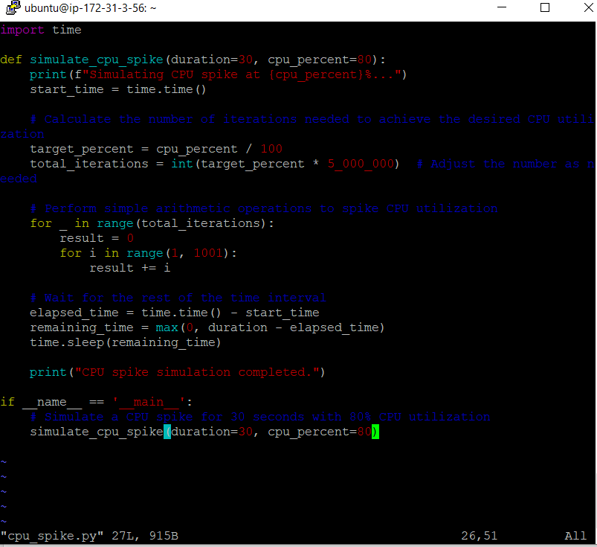

Run the command

$ python3 cpu_spike.py



Observe the CPU Utilization from the Metrics.

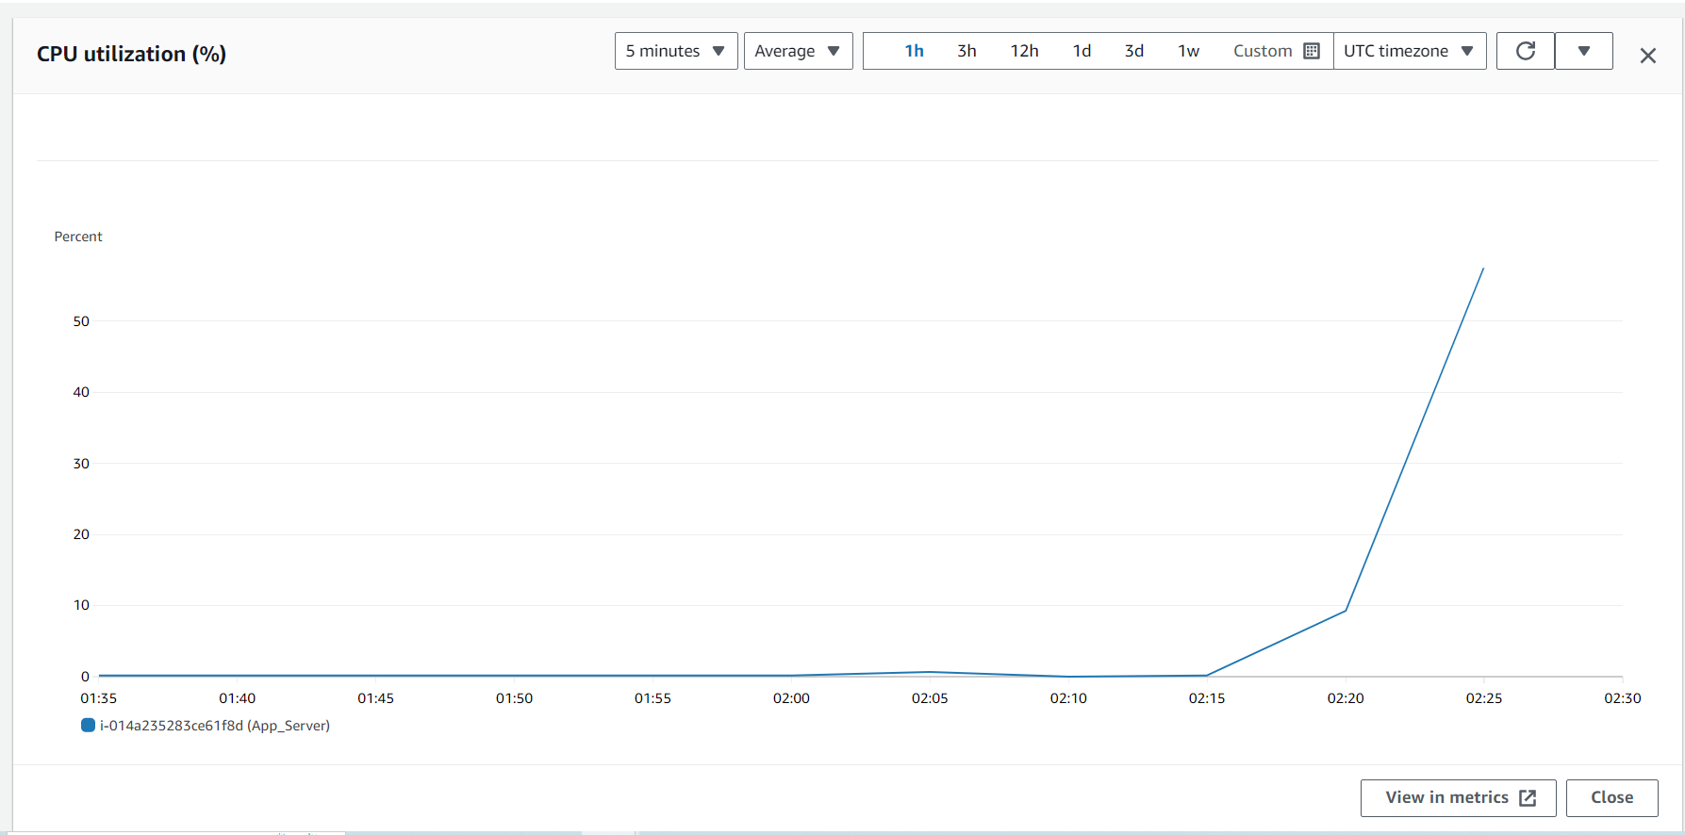

Navigate to Cloud watch and create an alarm notification for 50% Utilization of CPU

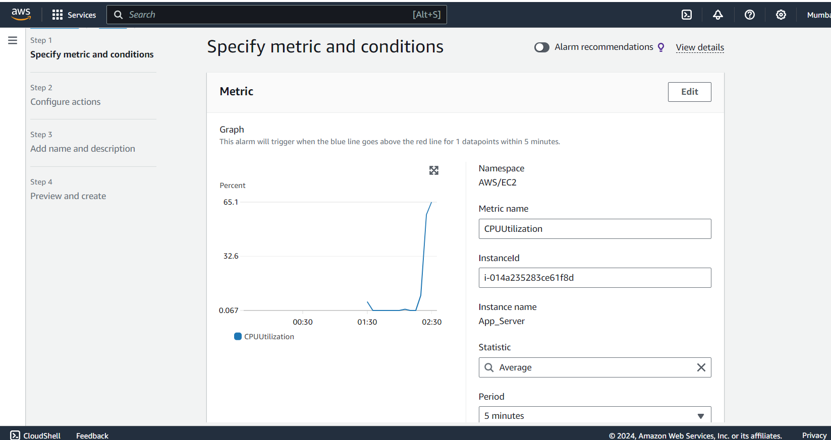

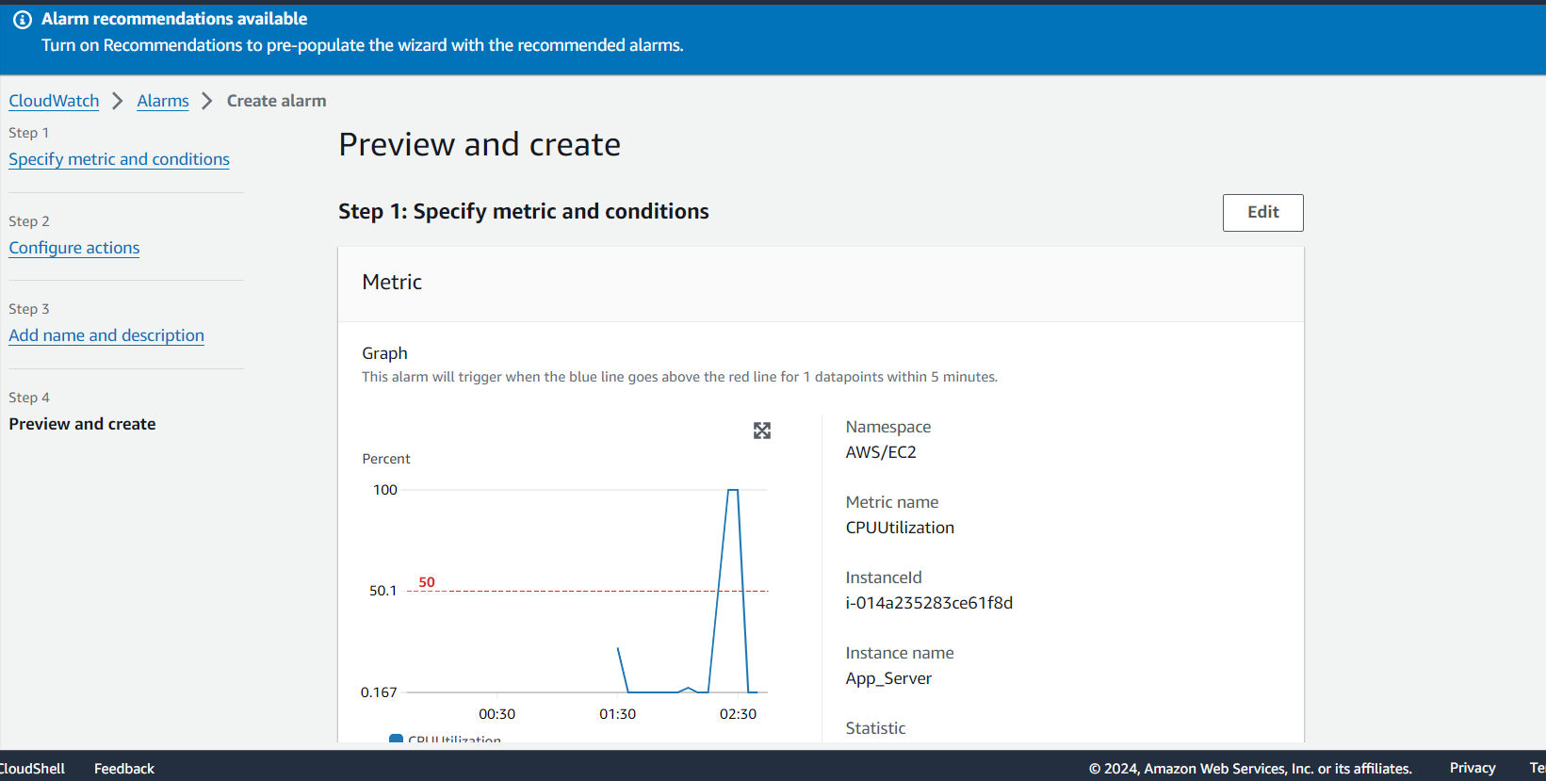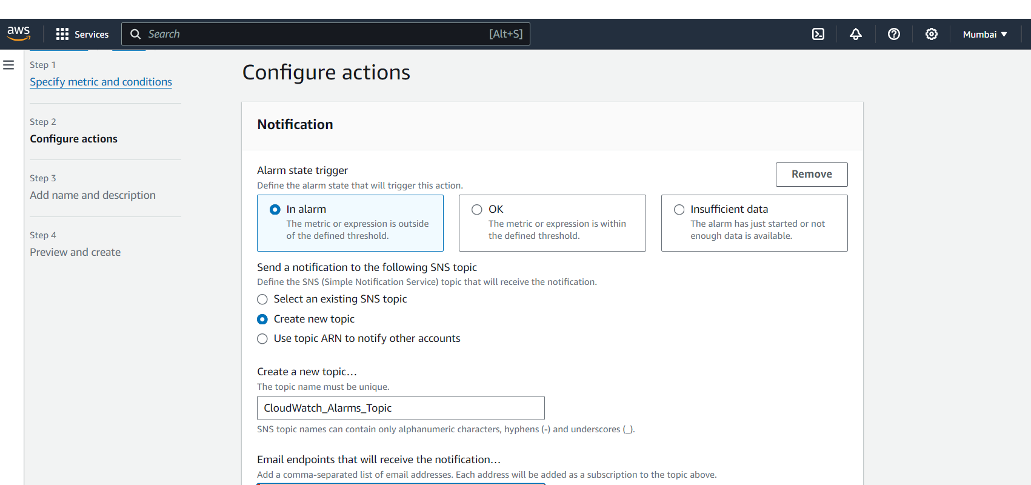

Provide a mail ID to which notification need to be sent, and confirm as below by logging

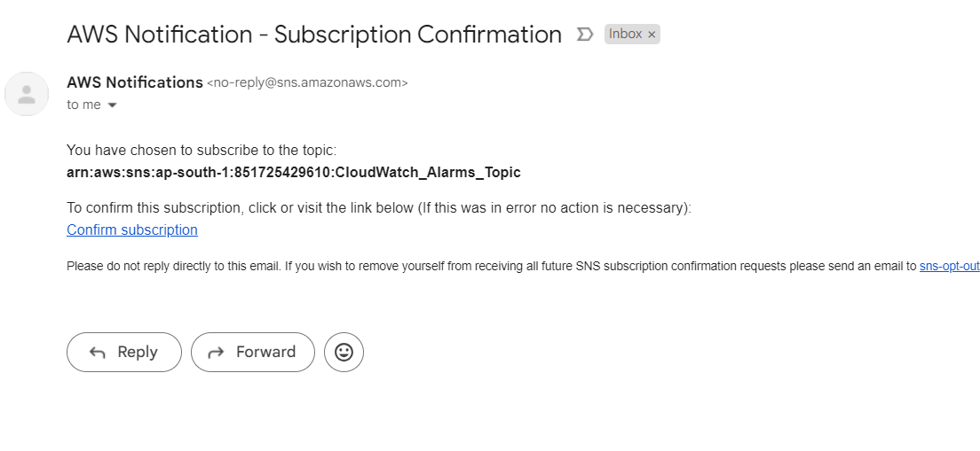

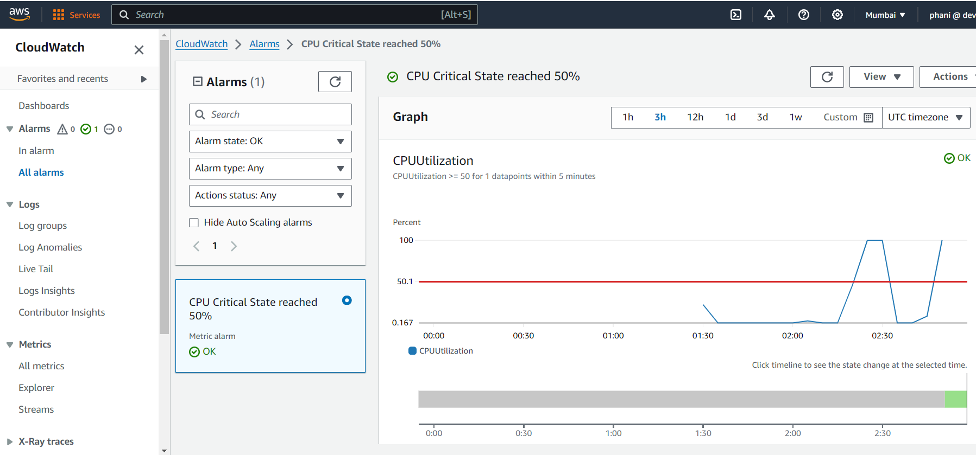

AS per the Condition we Provided once CPU Utilization reaches to >=50% it will trigger a Mail Notification and Alert .

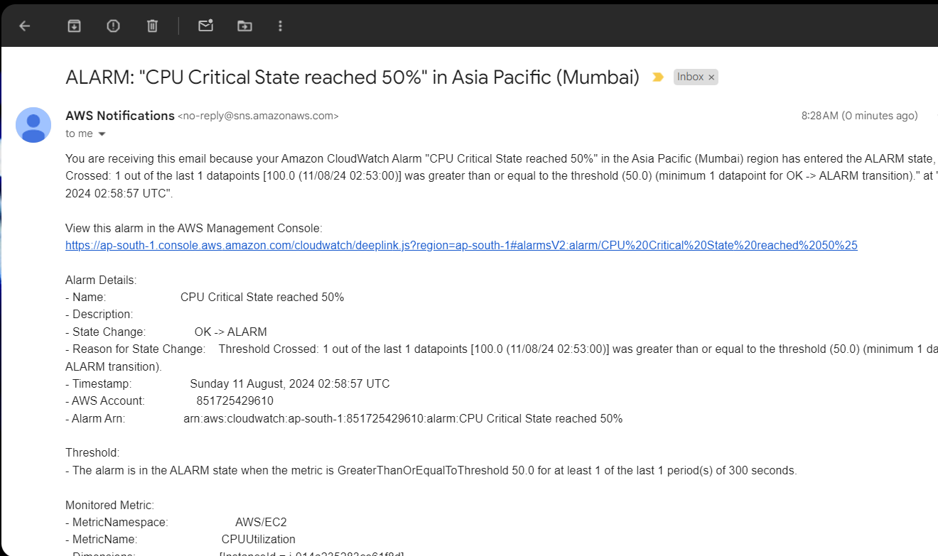

Thank you